Part 1

a) What properties does your class have, and what data type is each one?

The Rectangle class has two properties: width and height. Both properties are numbers because they represent the dimensions of the rectangle. These values are used by the methods to calculate the area and perimeter and to determine whether the rectangle is a square.

b) What is the purpose of the constructor in your class?

The constructor runs whenever a new Rectangle object is created. It initializes the width and height properties so each object stores its own dimensions and can use them in its methods.

c) How would you modify this class to prevent invalid data (e.g., a negative width or an empty song title)?

I would add validation inside the constructor to make sure the width and height are greater than or equal to zero. If either value is negative, the constructor could throw an error or set the value to 0 so the object always contains valid dimensions.


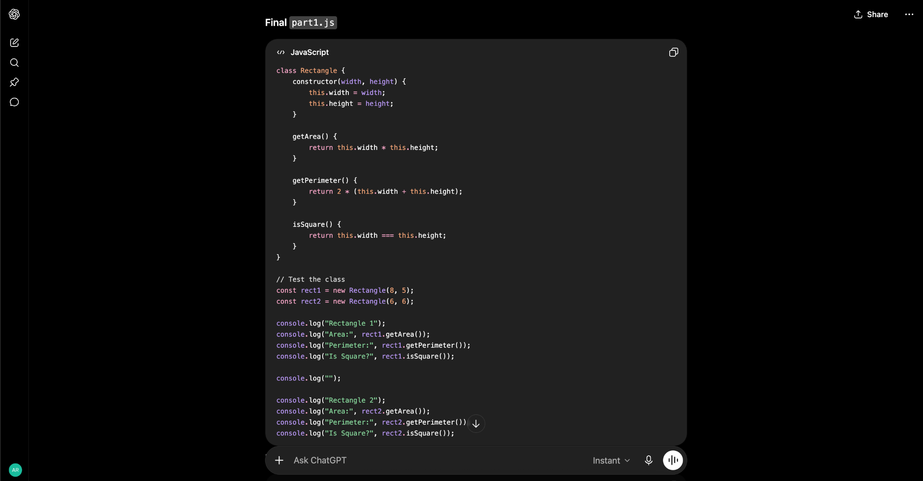

Part 2

Snippet A: Broken Constructor

Bug: The constructor assigns each parameter back to itself instead of saving the values as properties of the object. The this keyword is needed to create and assign the name and age properties.

Snippet B: Method vs. Property Confusion

Bug: The getInfo property is written as a string instead of a function, so it cannot be called with parentheses. It should be defined as a method so this refers to the car object when the method runs.

Snippet C: Inheritance Issue

Bug: The Student constructor tries to use this before calling the parent class constructor. A child class must call super() before it can access this, and the name and age values should be passed to the parent constructor.

Snippet D: Prototype Method Problem

Bug: The speak method uses an arrow function, which does not create its own this value. A regular function should be used so this refers to the specific Dog object that calls the method.

Part 3

What changed / why
- Converted the factory function into a Product class with a constructor to make the code more organized and object-oriented.
- Renamed the variables and methods (mk, n, p, q, d) to meaningful names like Product, name, price, discountPercent, and getSalePrice().
- Replaced all instances of var with const because the objects are not reassigned.
- Added comments above each method to explain what it does, making the code easier to understand.
- Added a toString() method so the product information can be displayed in a clean, readable format.

